Unit 3 Oral test

Speaking

Part 1:

Coralie Lassalle is a student at Lycée Voltaire. Below is her schedule. Record yourself reading both the questions and the answers aloud. Answer in full sentences (10 points)

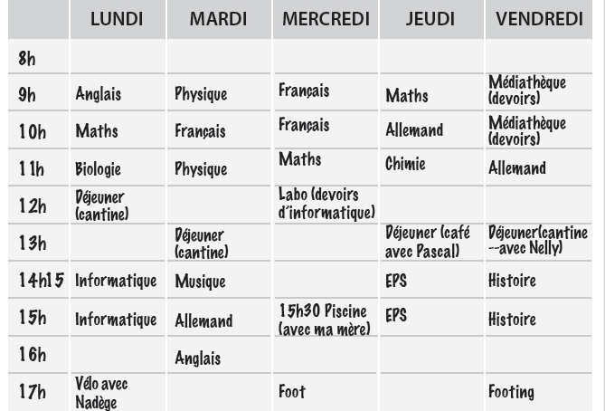

Questions:

1. Quand (quel jour et à quelle heure) est-ce que Coralie a cours de musique?
2. Où est-ce que Coralie et ses camarades vont le mercredi à midi? Pourquoi?
3. Qu’est-ce que Coralie fait le vendredi matin? Où?
4. Avec qui est-ce que Coralie va à la piscine le mercredi après-midi? À quelle heure?
5. Qu’est-ce que Coralie étudie le jeudi matin?

Part 2:

You are at a store shopping for school supplies. Create a dialogue in which a salesperson
answers your questions and helps you with your shopping needs. (10 points)

You: Ask the salesperson if the store has a school supply of your choice.
Salesperson: Answers that he does not have the supply you want.
You: Ask about two other supplies you need.
Salesperson: Tells you that he does have the items.
You: Ask how much the items cost.
Salesperson: Gives the price.
A

